Cricket Player Performance Tracking Application : CRICKSTATS

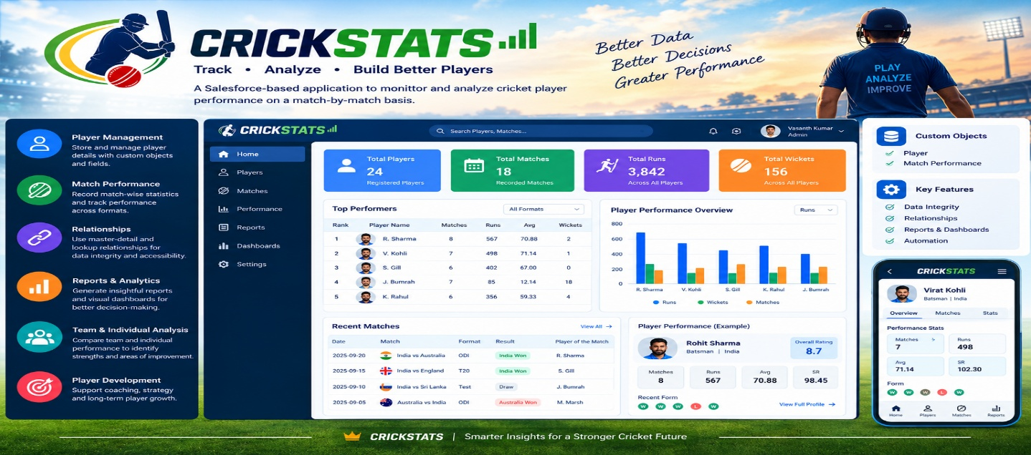

User Story:
As a Salesforce Admin, I want to create a comprehensive player performance tracking application within Salesforce to capture and analyze detailed match-by-match information of cricket players. This application will include custom objects such as Player and Match Performance with carefully defined fields and relationships to ensure data integrity and accessibility. By leveraging master-detail and lookup relationships, the application will enable robust tracking of individual and team performances, facilitate insightful reporting and analytics, and support the overall management of player statistics, thereby enhancing strategic decision-making and player development initiatives.

1. INTRODUCTION
1.1 Project Overview :

“CRICKSTATS is a Salesforce-based Cricket Player Performance Tracking Application. It stores player and match-performance information using custom objects and relationships. Salesforce reports and dashboards are used to analyze individual and team performance, while automation helps reduce repetitive tasks. The main goal is to provide a centralized system for managing cricket statistics and generating useful performance insights.”

1.2 Purpose :

- Digitize Player Performance Records – Store player and match performance data digitally in Salesforce.
- Improve Data Accuracy – Reduce manual errors and maintain accurate cricket statistics.
- Provide Real-Time Analytics – Generate reports and dashboards to analyze player performance.
- Support Player and Team Development – Help coaches and administrators make informed decisions.
- Automate Data Management – Use Salesforce automation to efficiently manage and update performance records.

2. IDEATION PHASE
2.1 Problem Statement

Problem Statement | I am (Customer) | I’m trying to | But | Because | Which makes me feel
PS-1 | A cricket team coach | Track player performance across matches | I cannot get accurate statistics easily | Data is stored in different files and formats | Frustrated
PS-2 | A team manager | Maintain complete player records | It takes too much time to update and verify data | Most records are maintained manually | Stressed
PS-3 | A sports analyst | Analyze player trends and generate reports | I face difficulty in comparing performances | There is no centralized analytics system | Confused

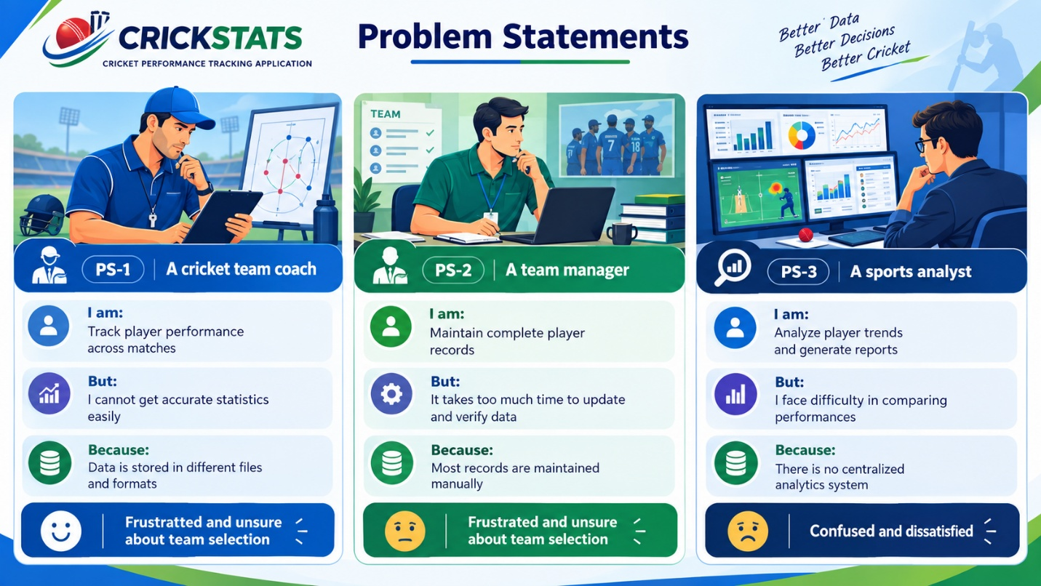

2.2 Empathy Map Canvas

No. | Empathy Aspect | Description
1 | Target Users | Team Managers, Coaches, Analysts, and Salesforce Admins
2 | Think & Feel | Need accurate player data and better performance insights
3 | Hear | Receive feedback and requirements from management
4 | See | Deal with multiple sources of player and match data
5 | Say & Do | Collect and manage cricket statistics manually
6 | Pain | Face data errors, delays, and difficulty in managing records
7 | Gain | Get faster decision-making, automation, and organized performance analysis
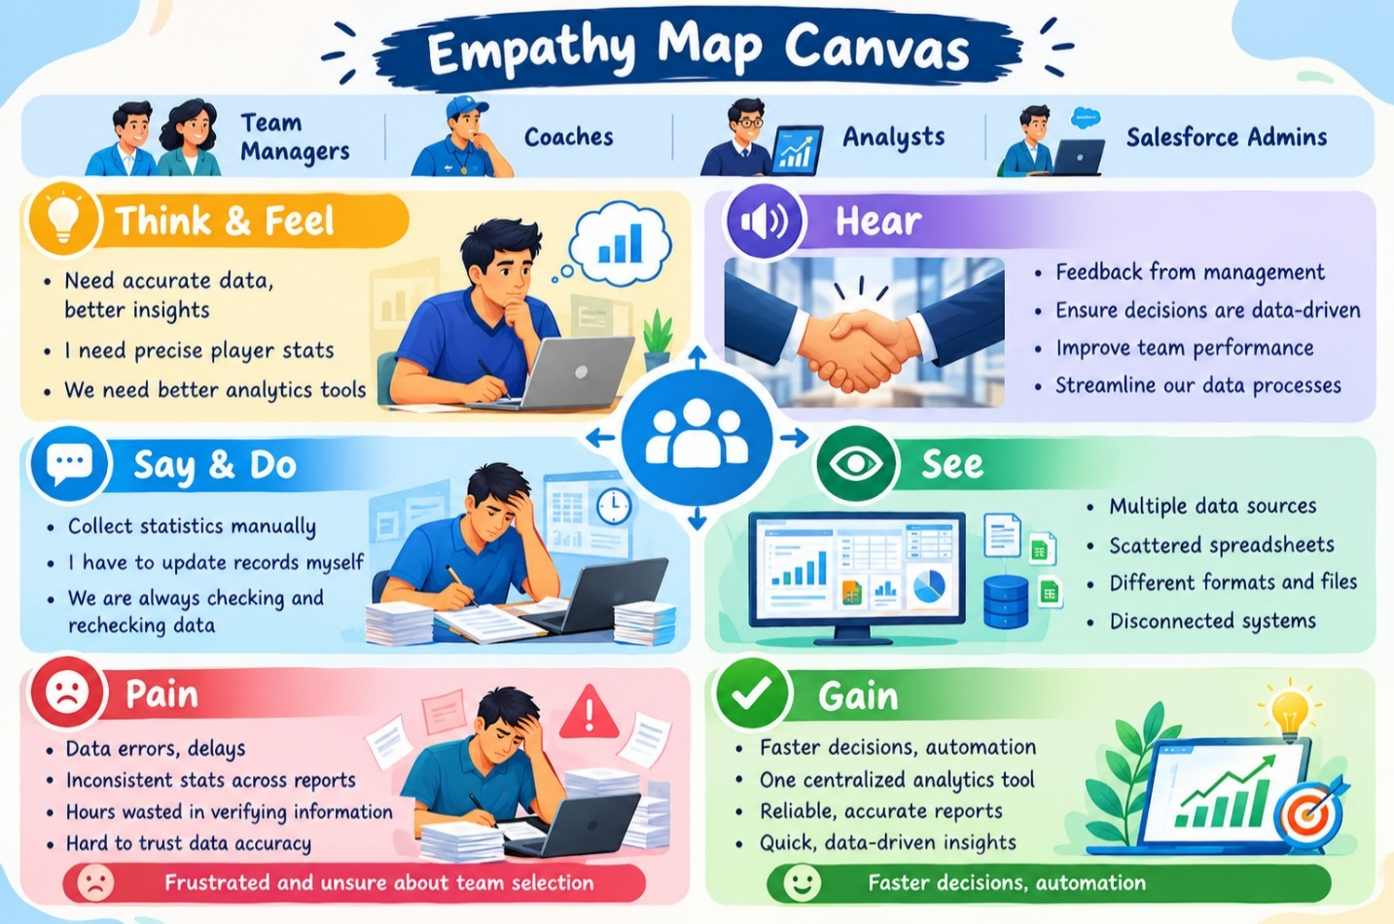

2.3 Brainstorming
Brainstormed Ideas

- Web-based Player Management System – Manage player details and match records online.
- Mobile Statistics Tracker – Track player performance and statistics through mobile devices.
- Salesforce-Integrated CRM – Store and manage cricket player data using Salesforce.
- AI-Based Performance Prediction – Analyze past data to predict future player performance.
- Dashboard-Based Analytics – Display player statistics, reports, and performance insights using dashboards.
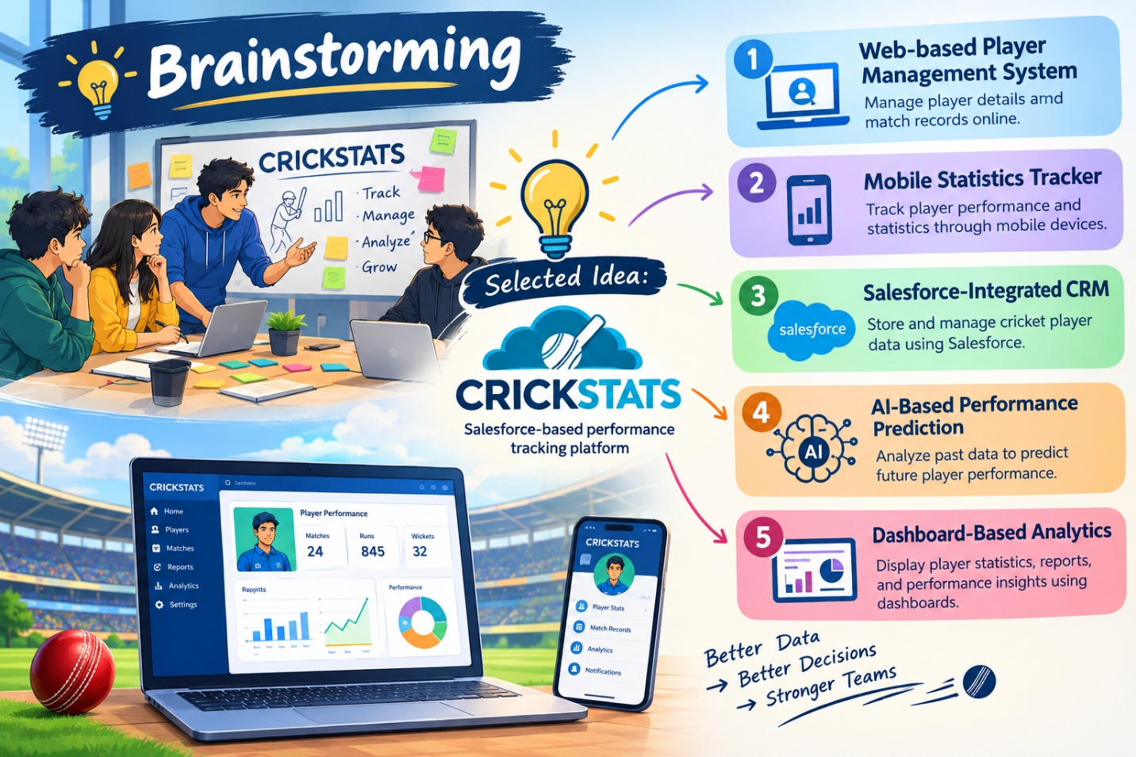

3.REQUIREMENT ANALYSIS PHASE

- Login & Access – User logs into the CRICKSTATS system.

- Enter & Record Data – Add player details and match performance statistics.

- Generate & Analyze Reports – Create reports and view performance insights.

- Decision Making – Use the analyzed results to support team and player decisions.

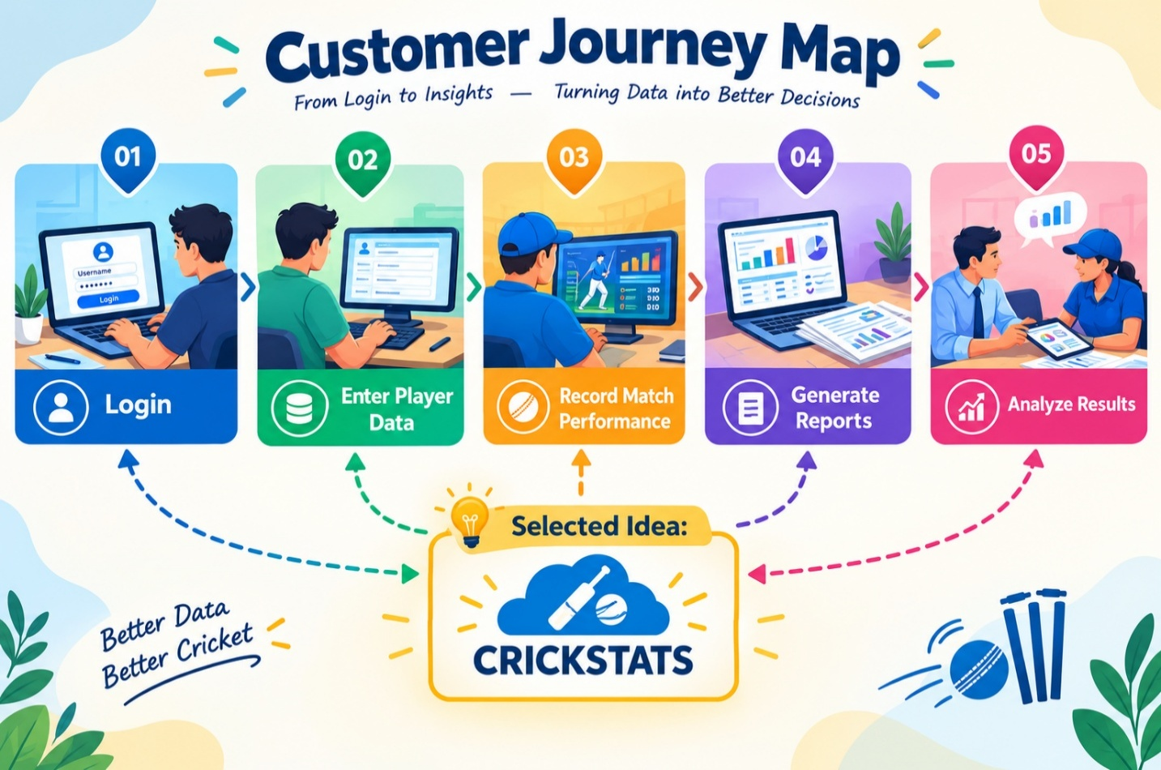

3.2 Solution Requirements
Functional Requirements

FR No | Requirement
FR-1 | Player Registration
FR-2 | Match Performance Entry
FR-3 | Dashboard Generation
FR-4 | Report Creation
FR-5 | Flow Automation

Non-Functional Requirements (NFRs) – CRICKSTATS

NFR-1: Usability
The system should be easy to understand and use by coaches, managers, analysts, and
admins without requiring technical training.
Requirements
- Simple and intuitive user interface
- Clear navigation menus
- Easy-to-read dashboards
- Minimal learning curve
Examples:
- A new coach should be able to:
- Log in
- Enter match data
- View player reports
- within a few minutes without special training.
Example: The Salesforce Lightning interface provides drag-and-drop dashboards and user-friendly forms.

NFR-2: Security
The system must protect sensitive player data from unauthorized access.
Requirements
- Role-based access control
- Secure authentication
- Encrypted data storage
- Regular backups
.
Examples:
- Coaches can view player statistics
- Managers can edit records
- Analysts can generate reports
- Only admins can modify system settings
Example: Salesforce Profiles and Permission Sets restrict access to confidential information.

NFR-3: Reliability
The system should function correctly without failure and store data accurately.
Requirements
- No data loss
- Automatic backups
- Error handling
- System stability
Example:
If a manager enters match statistics and loses internet connection, the data should be saved automatically when reconnected.
Salesforce cloud backup ensures recovery in case of system failure.

NFR-4: Performance
The system should respond quickly and handle large volumes of data efficiently.
Requirements
- Fast page loading
- Quick report generation
- Smooth dashboard rendering
- Minimal response time
Example:
When an analyst generates a performance report for 100+ players, the report should load within 2–3 seconds.
Optimized Salesforce queries and caching improve response speed.

NFR-5: Availability
The system should be accessible whenever users need it.
Requirements
- 24/7 system availability
- Minimal downtime
- Cloud-based access
- Disaster recovery
Example:
Coaches should be able to access CRICKSTATS even during tournaments at night or on weekends.
Salesforce provides high uptime with cloud hosting.

NFR-6: Scalability
The system should support increasing numbers of users, players, and records.
Requirements
- Handle growing datasets
- Support more teams and leagues
- Expand storage capacity
- Maintain performance under load
Example:
If CRICKSTATS is extended from one team to 50 teams, the system should still perform smoothly.
Salesforce cloud infrastructure automatically scales storage and processing.

3.3 Data Flow Diagram
Data Flow
User → Salesforce UI → Player Object → Match Performance → Reports → Dashboard

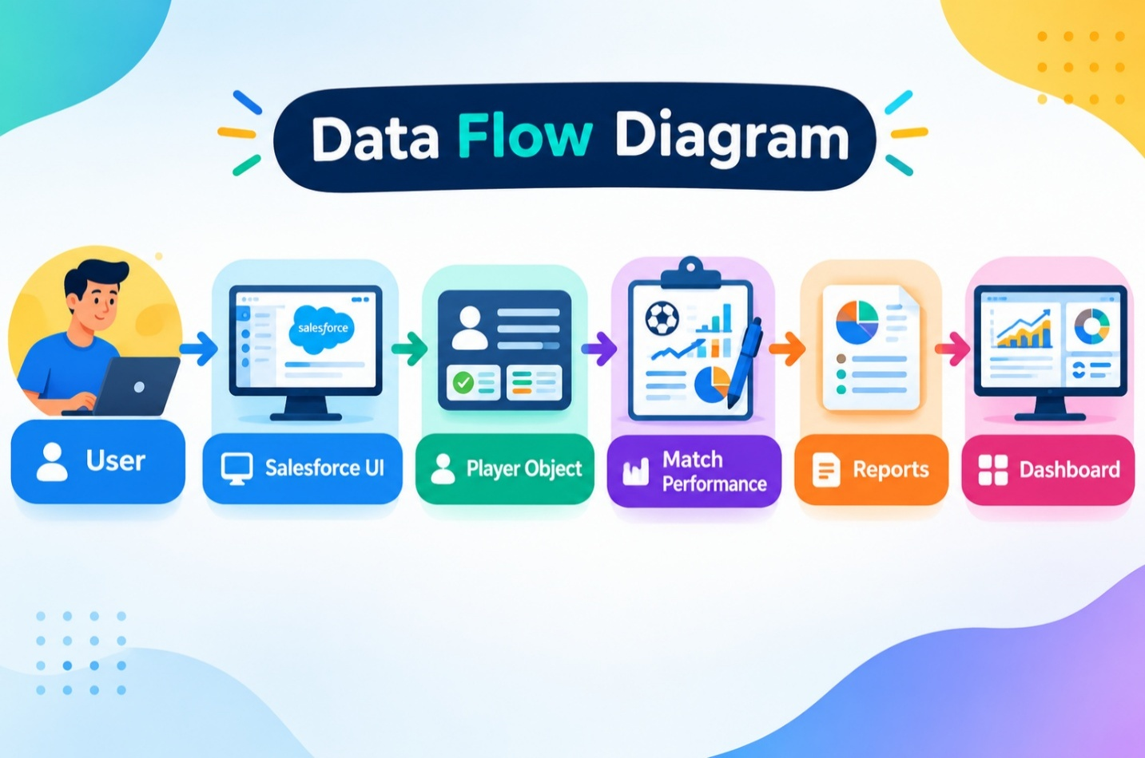

3.4 Technology Stack
Layer | Technology
Frontend | Salesforce Lightning
Analytics | Reports & Dashboards
Automation | Salesforce Flows
Backend | Salesforce Objects
Database | Salesforce Cloud

4. PROJECT DESIGN PHASE

4.1 Problem–Solution Fit

The CRICKSTATS system provides a modern and efficient solution for managing cricket player and match performance data. It replaces traditional manual record-keeping with an automated Salesforce-based system, reducing errors and saving time. Secure cloud storage helps prevent data loss and makes information easy to access. Interactive dashboards organize performance data and provide clear visual insights for better analysis. Real-time reports also allow coaches, managers, and analysts to quickly access important information and make informed decisions. Overall, CRICKSTATS improves data accuracy, storage, analysis, reporting, and performance management through modern technology.

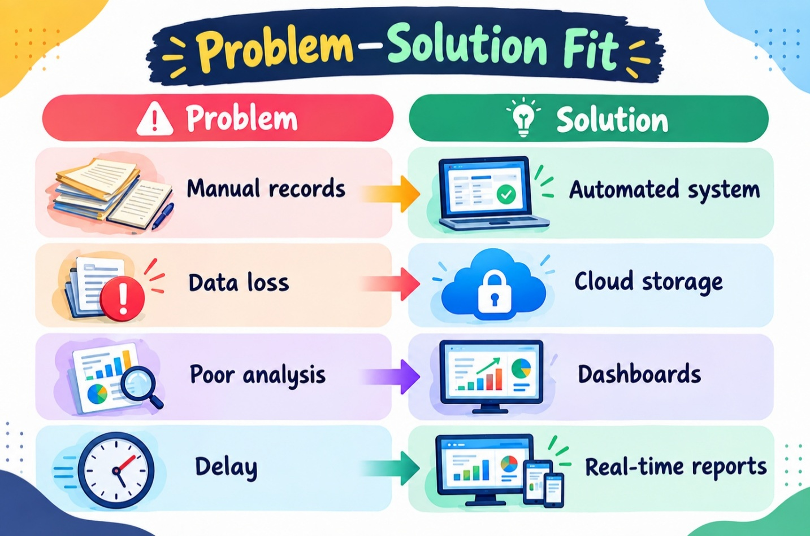

4.2 Proposed Solution
Description
CRICKSTATS provides:

Custom Objects – Stores player and match performance details.

Master-Detail Relationships – Connects players with their match records.

Roll-Up Summaries – Automatically calculates overall player statistics.

Lightning App & Automated Flows – Provides an easy interface and automates processes.

Interactive Dashboards – Displays player and match performance through charts and reports.

Key Features
- Centralized Database – Stores all cricket data in one place.
- Live Statistics – Provides real-time player and match statistics.
- Secure Access – Protects data with controlled user access.
- Scalable Design – Can easily support future growth and additional features.
- Easy Reporting – Generates clear and useful reports quickly.
.
4.3 Solution Architecture
Architecture Layers

- Presentation Layer – Provides a user-friendly Lightning interface.
- Application Layer – Handles business logic and automated processes.
- Data Layer – Stores player, match, and performance data.
- Analytics Layer – Generates reports and performance insights.
- User Interaction – Allows coaches and managers to access data easily.
- Automation – Uses Salesforce Flows to automate tasks and updates.
- Centralized System – Connects all layers for efficient cricket data management.
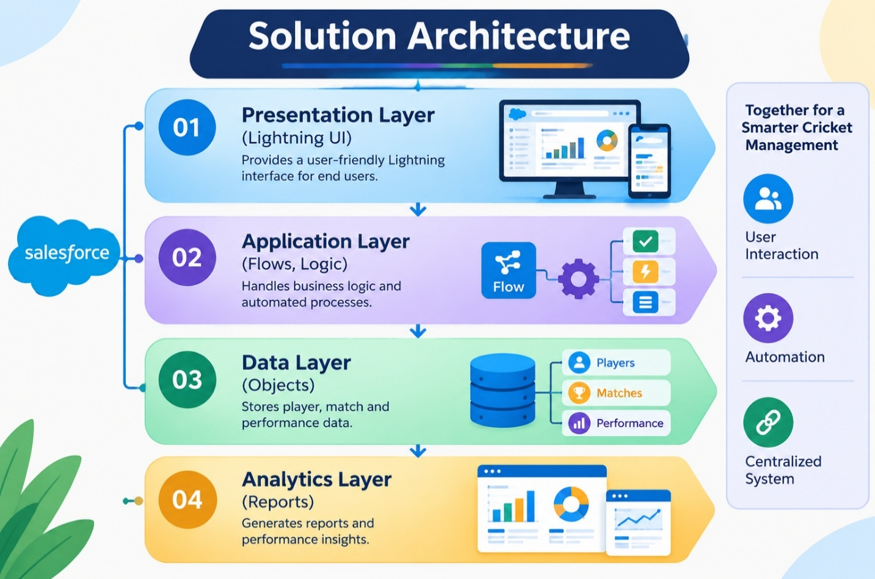

5. PROJECT PLANNING & SCHEDULING

5.1 Project Planning
- Agile-based project execution.
- Define project goals and requirements.
- Create a step-by-step development plan.
- Develop custom objects in Salesforce.
- Establish relationships between objects.
- Implement automated workflows and flows.
- Create reports and interactive dashboards.
- Conduct sprint-wise testing and improvements.

Product Backlog, Sprint Schedule, and Estimation:

Sprint | Functional Requirement (Epic) | User Story Number | User Story / Task | Story Points | Priority | Team Members
Sprint-1 | Developer Setup | USN-1 | As an admin, I want to create a Salesforce developer account so that I can configure and deploy the CRICKSTATS system. | 1 | High | Member1
Sprint-1 | Data Modeling | USN-2 | As an admin, I want to create Player and Match Performance objects so that player and match data can be stored systematically. | 3 | High | Member2
Sprint-2 | Navigation | USN-3 | As a user, I want separate tabs for each object so that I can easily navigate and manage records within the application. | 3 | High | Member3
Sprint-2 | UI Design | USN-4 | As a coach, I want a dedicated Lightning App so that all performance tracking features are accessible from one dashboard. | 3 | High | Member4
Sprint-2 | Data Structure | USN-5 | As an admin, I want to create player and match fields so that complete performance details can be captured accurately. | 5 | Medium | Member1
Sprint-2 | Data Structure | USN-6 | As a user, I want customized page layouts so that only relevant fields are displayed during data entry. | 5 | High | Member2
Sprint-2 | Automation | USN-7 | As a system, I want to validate player and match inputs so that incorrect data entries are prevented. | 3 | High | Member4
Sprint-3 | Automation | USN-8 | As a system, I want automated flows to update player statistics so that performance data remains accurate. | 5 | High | Member1

Project Tracker, Velocity & Burndown Chart:

Sprint | Total Story Points | Duration | Sprint Start Date | Sprint End Date (Planned) | Story Points Completed (as on Planned End Date) | Sprint Release Date (Actual)
Sprint-1 | 20 | 6 Days | 24 Oct 2022 | 29 Oct 2022 | 20 | 29 Oct 2022
Sprint-2 | 20 | 6 Days | 31 Oct 2022 | 05 Nov 2022
Sprint-3 | 20 | 6 Days | 07 Nov 2022 | 12 Nov 2022
Sprint-4 | 20 | 6 Days | 14 Nov 2022 | 19 Nov 2022

6. Project Development Phase:

Project Flow

- Milestone 1 : Creation of developer account
- Milestone 2 : Object Creation
- Milestone 3 : Tabs Milestone
- Milestone 4 : The Lightning App
- Milestone 5 : Fields & Relationships
- Milestone 6 : Roll-up Summary
- Milestone 7 : Flows

Implementation

Milestone 1 - Salesforce developer account creation :

Activity 1: Creating Developer Account:

Creating a developer org in salesforce.
- Go to http://developer.salesforce.com/signup
- On the sign up form, enter the following details :

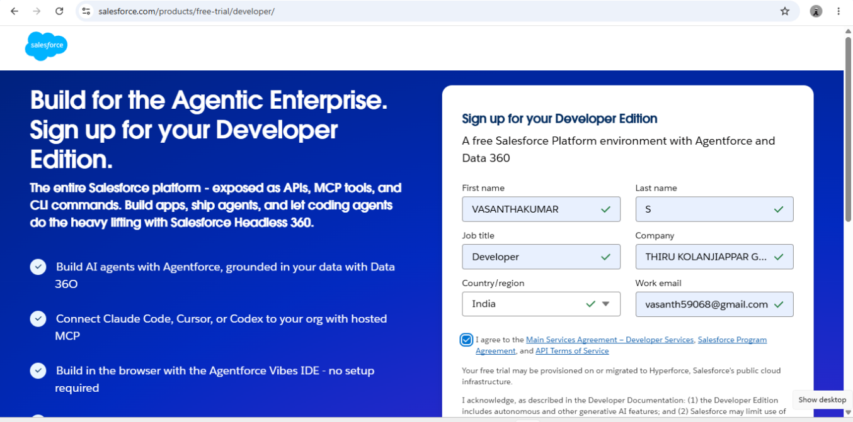

- First name & Last name
- Email
- Role : Developer
- Company : College or Company Name
- County : India
- Postal Code : pin code
- Username : should be a combination of your name and company
This need not be an actual email id, you can give anything in that format : username@organization.com
Click on sign me up after filling these.

Activity 2: Account Activation :

- Go to the inbox of the email that you used while signing up. Click on the verify account to activate your account. The email may take 5-10mins.

- Click on Verify Account.
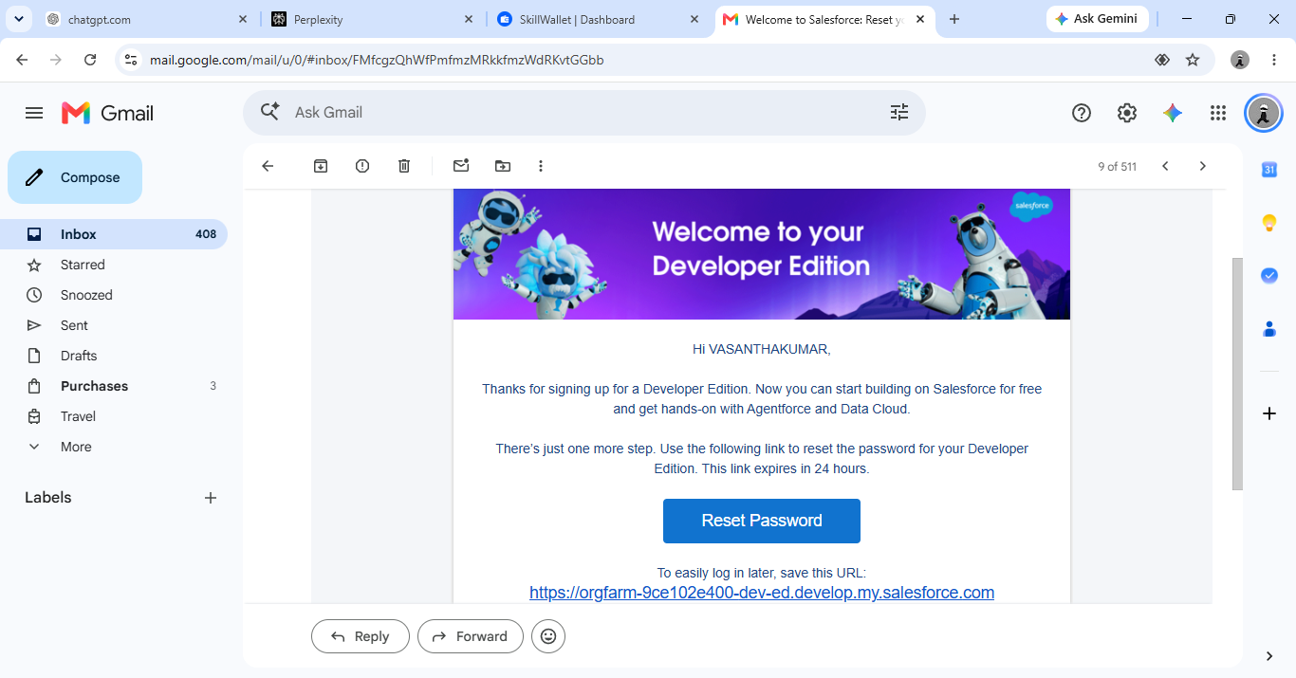

- Give a password and answer a security question and click on change password.

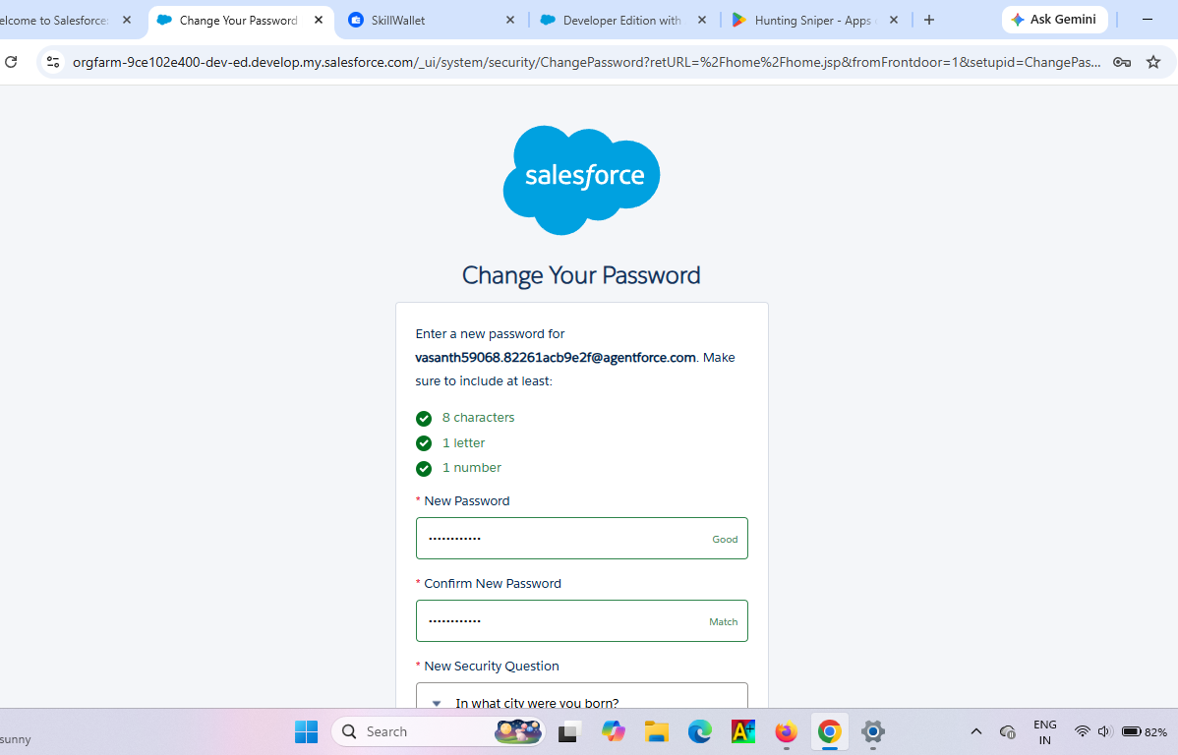

- Then you will redirect to your salesforce setup page.

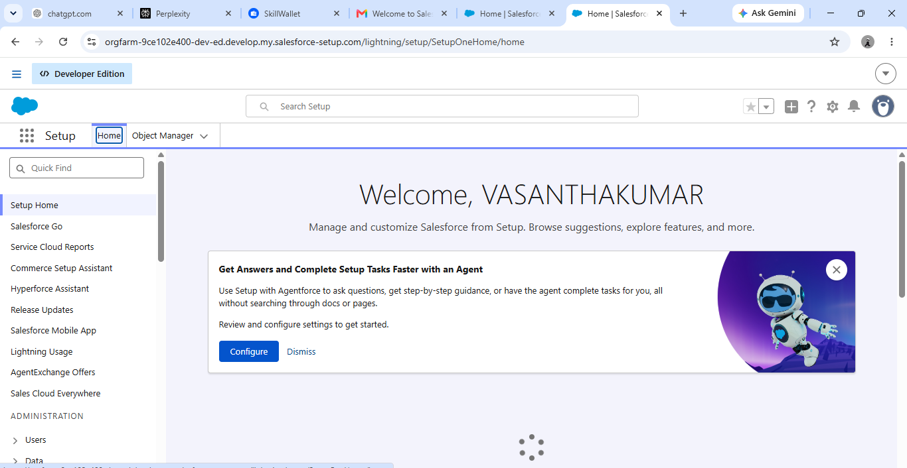

Milestone 2 - Object Creation

Activity 1 : Player Object

- In your Salesforce org, click gear icon on the top left and select Setup to open Setup.
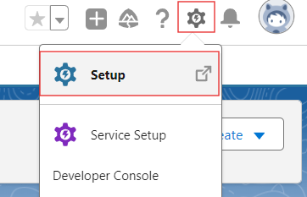

- Click the Object Manager tab. If you don’t see it, enter Object Manager in the Quick Find box.
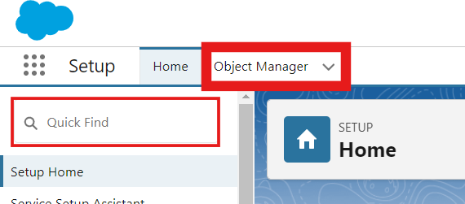

- On the Object Manager page, click Create | Custom Object.


- From the setup page → Click on Object Manager → Click on Create → Click on Custom Object.
- Label : Player
- Plural Label : Players
- Enter Record Name Label and Format
Record Name : Player Name
Data Type : Text
- In Optional features : check the boxes for Allow Reports | Allow Activities | Track Field History.
- Search Status : check the box for Allow Search.
- Save

Activity 2 : Match Performance Object

- From the setup page → Click on Object Manager → Click on Create → Click on Custom Object.
- Label : Match Performance
- Plural Label : Match Performances
- Enter Record Name Label and Format
Record Name : Customer Account Name
Data Type : Text
- In Optional features : check the boxes for Allow Reports | Allow Activities | Track Field History.
- Search Status : check the box for Allow Search.
- Save.

Milestone 3 - Tabs

Activity 1 : Custom tabs creation

- Go to setup page → type Tabs in Quick Find bar → click on tabs → New (under custom object tab)
- Select Object(Player) → Select the tab style → Next (Add to profiles page) keep it as default → Next (Add to Custom App) uncheck the include tab .
- Make sure that the Append tab to users' existing personal customizations is checked.
- Click save.
- Repeat the same steps for Match Performances.

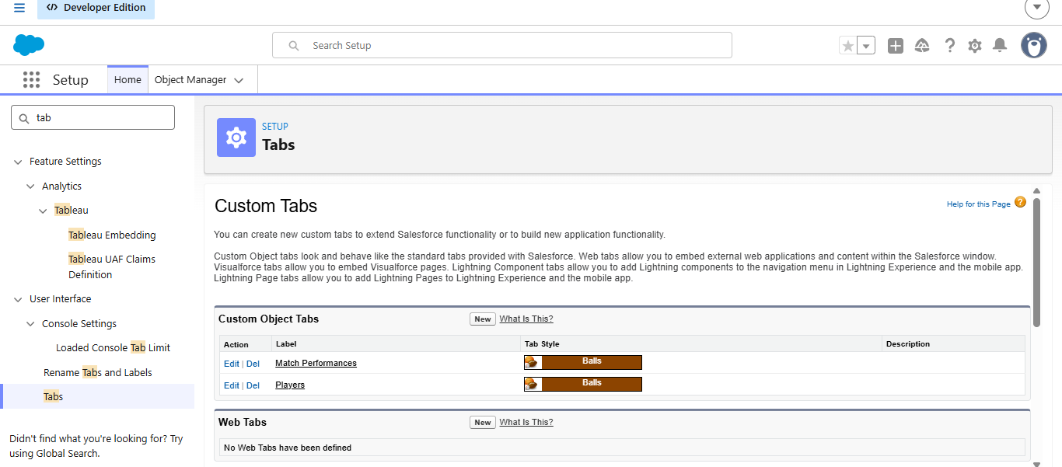

Milestone 4 - The Lightning App

Activity 1 : Create a lightning app

- Go to setup page → search “app manager” in quick find → select “app manager” → click on New lightning App.

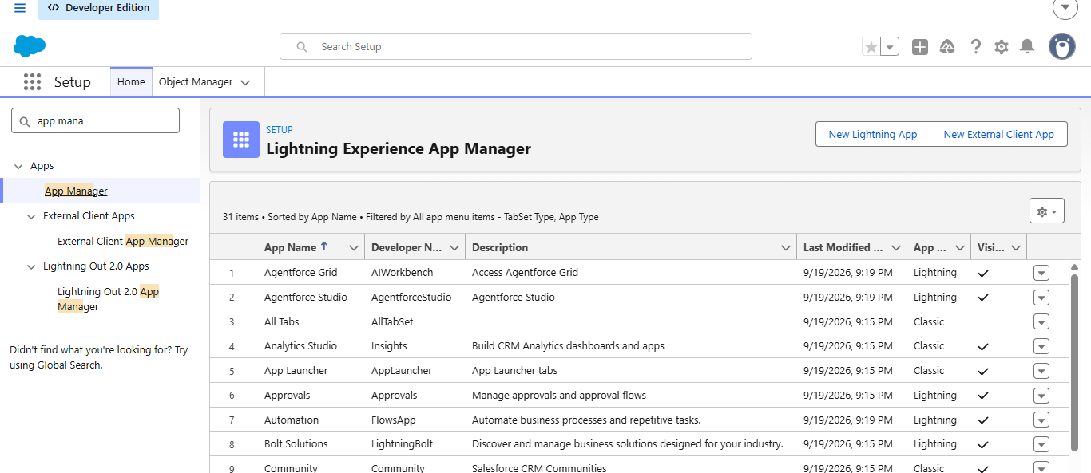

- Fill the app name in app details and branding as follow
App Name : CRICKSTATS
Developer Name : Auto Populates
Add image optional (if you want to give any image you can otherwise not mandatory) - Add Primary color Hex or leave it to default.
Then click Next.

- In App options
Navigation style : Standard navigation
Setup experience : setup
Supporters form factors : Desktop and phone
Then click Next

- In Utility items
Utility Bar alignment : Default
Then click Next.

- Navigation items
Select the created Custom Objects and required standard objects
- Players
Match Performances
Reports
Dashboards

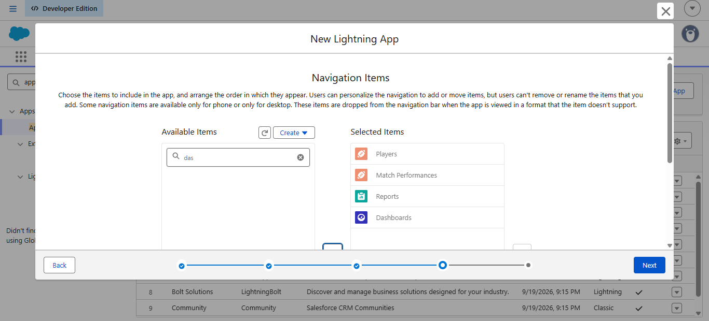
- To Add User Profiles : System Administrator
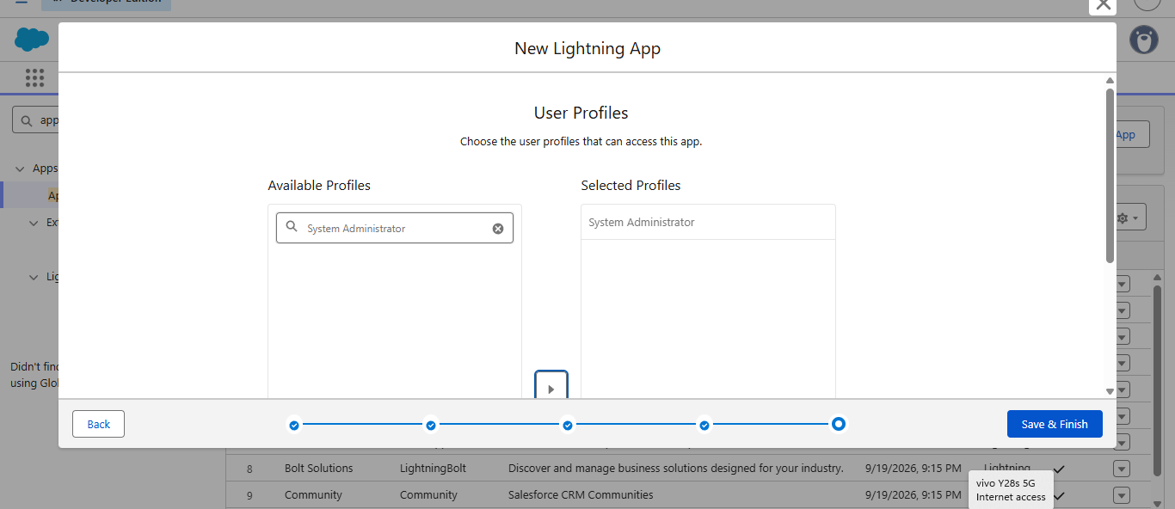
- Click Save & Finish.

Milestone 5 : Fields & Relationships

Activity 1 : Create Custom fields for Player object

- In your Salesforce org, click gear icon on the top left and select Setup to open Setup.
- Click the Object Manager tab. If you don’t see it, enter Object Manager in the Quick Find box.
- From the object manager page, In the Quick Find box, Search for the custom object you just created : Player
- From the sidebar, click Fields & Relationships. Notice that there are already some fields there. Those are the standard fields.
- Click New to create a custom field. Tip: Before creating a new field, do a quick search to make sure a similar one doesn’t already exist.
- Next, choose a data type as Text. Choosing a data type helps you format the field input.

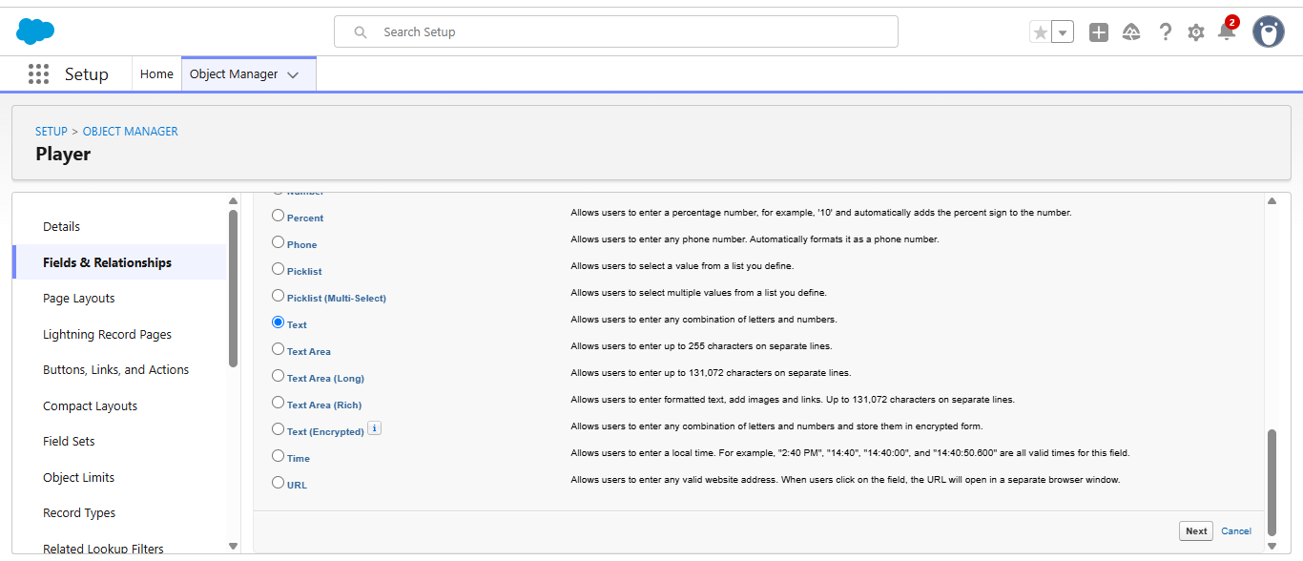

- Click on next.

- Data Type : Text
Field Label: Player Name
Field Name : Auto Populates
Length : 50
Click on Next → Next → Save and new.

- Repeat the Same steps for remaining fields

- Data Type : Text
Field Label: Player Number
Field Name : Auto Populates
Length : 3
Click on Next → Next → Save and new.

- Data Type : Rich Text Area
Field Label : Profile Picture
Field Name : Auto Populates
Click on Next → Next → Save and new.

- Data Type : Date
Field Label : Date of Birth
Field Name : Auto Populates
Click on Next → Next → Save and new.

- Data Type : Picklist
Field Label : Role
Field Name : Auto Populates
Value : Enter value, with each value separated by a new line.
Batsman
Bowler
Batsman & Wicket Keeper
All Rounder

- Data Type : Picklist
Field Label : Batting Style
Field Name : Auto Populates
Value : Enter value, with each value separated by a new line.
Right- Handed
Left - Handed
Click on Next → Next → Save and new.

- Data Type : Picklist
Field Label : Bowling Style
Field Name : Auto Populates
Value : Enter value, with each value separated by a new line.
Right-Arm Fast
Left-Arm Fast
Right-Arm Medium
Left-Arm Medium
Right-Arm Spin
Left-Arm Spin
Click on Next → Next → Save and new.

- Data Type : Picklist
Field Label : Nationality
Field Name : Auto Populates
Value : Enter value, with each value separated by a new line.
Australia
Bangladesh
England
India
New Zealand
Pakistan
South Africa
Sri Lanka
West Indies
Afghanistan
Zimbabwe
Ireland
Scotland
Netherlands
United Arab Emirates
Nepal
United States of America
Click on Next → Next → Save and new.

- Data Type : Picklist
Field Label : Team
Field Name : Auto Populates
Value : Enter value, with each value separated by a new line
Chennai Super Kings (CSK)
Delhi Capitals (DC)
Kolkata Knight Riders (KKR)
Mumbai Indians (MI)
Punjab Kings (PBKS)
Rajasthan Royals (RR)
Royal Challengers Bangalore (RCB)
Sunrisers Hyderabad (SRH)
Gujarat Titans (GT)
Lucknow SuperGiants (LSG)
- Data Type : Formula
Field Label : AVG Score
Field Name : Auto Populates
Formula Return : Number
Formula : IF(
Matches_Played__c > 0,
Total_Runs__c / Matches_Played__c ,
0
)

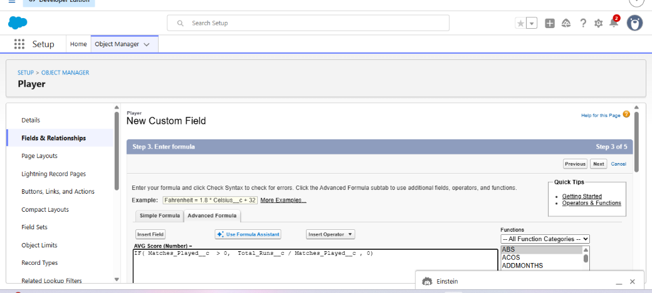

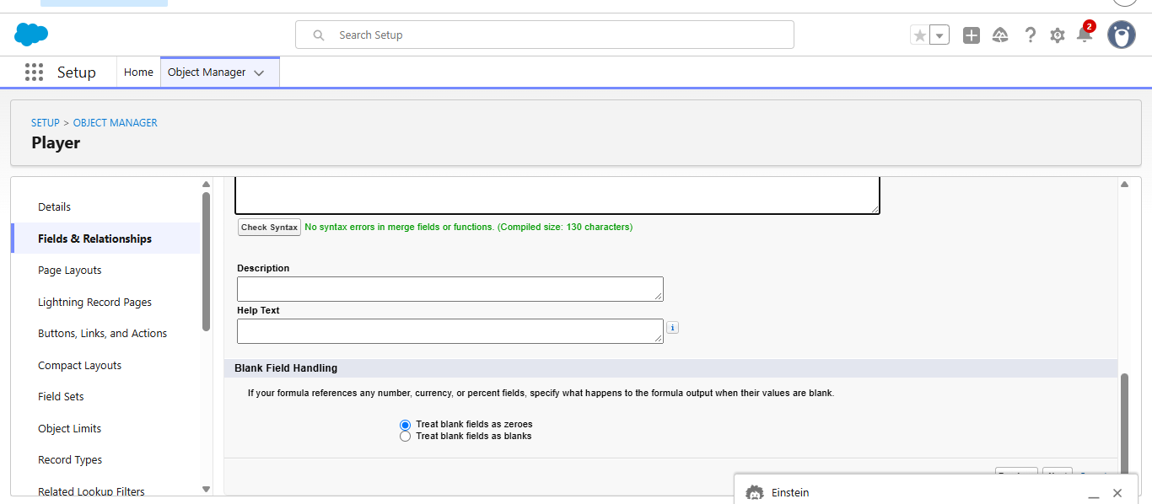
Click on Next → Next → Save & New.

- Data Type : Lookup Relationship
Related To : Match Performance
Field Label : Match Performance
Field Name : Auto Populates
Click on Next → Next → Save.

Activity 2 : Create Custom fields for Match Performance object.

- Data Type : Text
Field Label: Match Performance Name
Field Name : Auto Populates
Length : 80
Click on Next → Next → Save and new.

- Data Type : Checkbox
Field Label: Player of the Match
Field Name : Auto Populates
Click on Next → Next → Save and new.

- Data Type : Picklist
Field Label: Match Result
Field Name : Auto Populates
Value : Enter value, with each value separated by a new line
WON
LOST
DRAW
Click on Next → Next → Save and new.

- Data Type : Number
Field Label: Runs Scored
Field Name : Auto Populates
Click on Next → Next → Save and new.

- Data Type : Number
Field Label: Balls Faced
Field Name : Auto Populates
Click on Next → Next → Save and new.

- Data Type : Number
Field Label: Fours
Field Name : Auto Populates
Click on Next → Next → Save and new.

- Data Type : Number
Field Label: Sixes
Field Name : Auto Populates
Click on Next → Next → Save and new.

- Data Type : Number
Field Label: Overs Bowled
Field Name : Auto Populates
Click on Next → Next → Save and new.

- Data Type : Number
Field Label: Wickets Taken
Field Name : Auto Populates
Click on Next → Next → Save and new.

- Data Type : Number
Field Label: Runs Conceded
Field Name : Auto Populates
Click on Next → Next → Save and new.

- Data Type : Number
Field Label: Maiden Overs
Field Name : Auto Populates
Click on Next → Next → Save and new.

- Data Type : Number
Field Label: Stumpings
Field Name : Auto Populates
Click on Next → Next → Save and new

- Data Type : Number
Field Label: Catches
Field Name : Auto Populates
Click on Next → Next → Save and new.

- Data Type : Master - Detail Relationship
Related To : Player
Field Label : Player
Field Name : Auto Populates
Click on Next → Next → Save.

Milestone 6 : Roll-up Summary

Activity 1 : Create Roll-up Summary for Player object.

Note :- Roll-up Summary can only be created on parent object in Master- Detail Relationship.

- In your Salesforce org, click gear icon on the top left and select Setup to open Setup.
- Click the Object Manager tab. If you don’t see it, enter Object Manager in the Quick Find box.
- From the object manager page, In the Quick Find box, Search for the custom object you just created : Player
- From the sidebar, click Fields & Relationships. Notice that there are already some fields there. Those are the standard fields.
- Click New to create a custom field. Tip: Before creating a new field, do a quick search to make sure a similar one doesn’t already exist. Click Next,
- Choose a data type as Roll-up Summary. Click Next.
Field Label: Matches Played
Field Name : Auto Populates
Summarized Object : Match Performances
Select Roll-up Type : COUNT

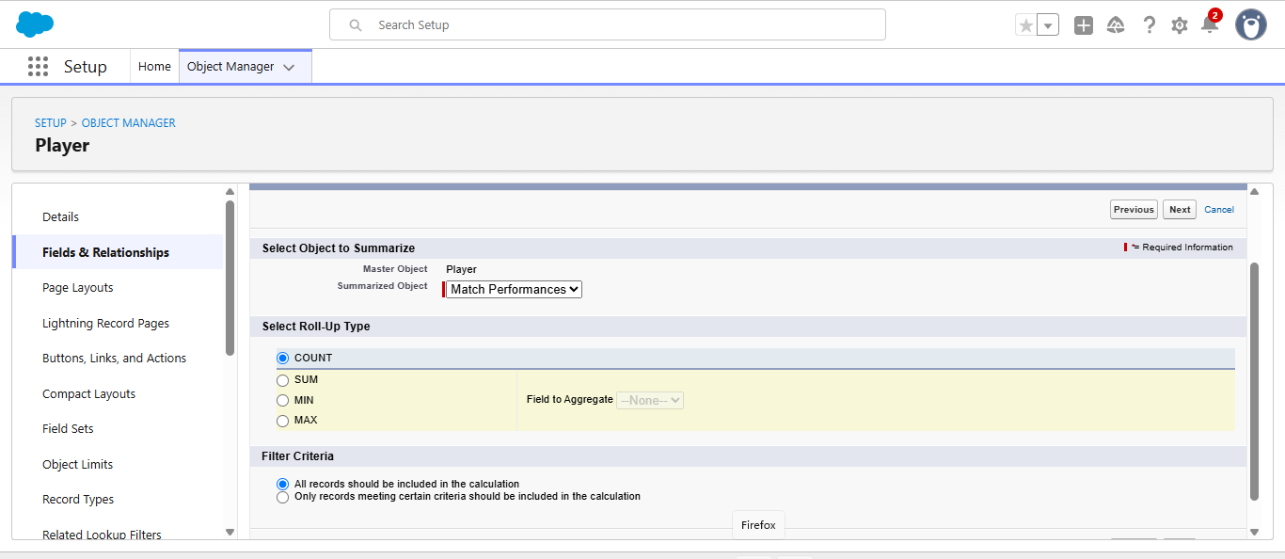

Filter Criteria : All records should be included in the calculation.
Click on Next → Next → Save and new.

- Data Type : Roll-up Summary
Field Label: Number of 50’s
Field Name : Auto Populates
Summarized Object : Match Performances
Select Roll-up Type : COUNT
Filter Criteria : Only records meeting certain criteria should be included in the calculation.
Click on Next → Next → Save and new.
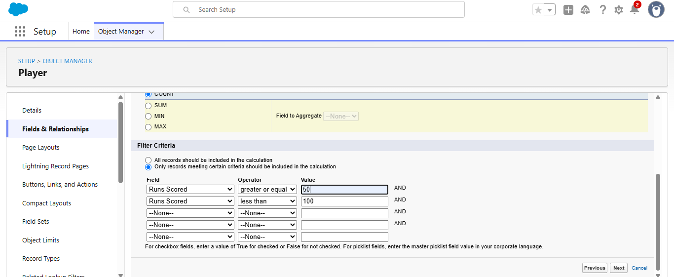

- Data Type : Roll-up Summary
Field Label: Number of 100’s
Field Name : Auto Populates
Summarized Object : Match Performances
Select Roll-up Type : COUNT
Filter Criteria : Only records meeting certain criteria should be included in the calculation.
Click on Next → Next → Save and new.

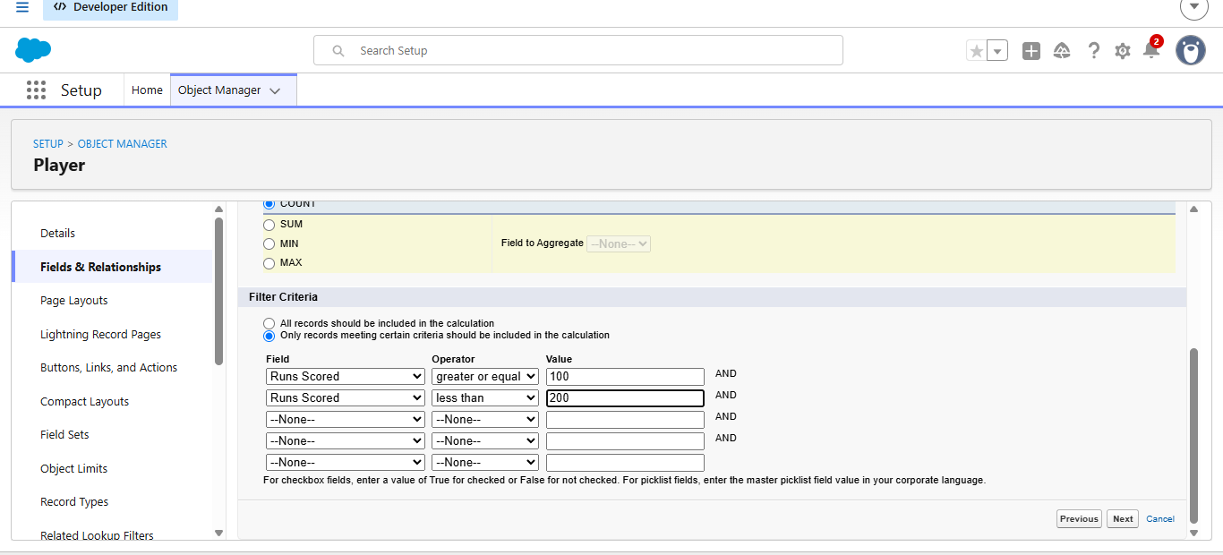

- Data Type : Roll-up Summary
Field Label: Total 4’s
Field Name : Auto Populates
Summarized Object : Match Performances
Select Roll-up Type : SUM
Field To Aggregate : Fours
Filter Criteria : All records should be included in the calculation.
Click on Next → Next → Save and new.

- Data Type : Roll-up Summary
Field Label: Total 6’s
Field Name : Auto Populates
Summarized Object : Match Performances
Select Roll-up Type : SUM
Field To Aggregate : Sixes
Filter Criteria : All records should be included in the calculation.
Click on Next → Next → Save and new.

- Data Type : Roll-up Summary
Field Label: Total Runs
Field Name : Auto Populates
Summarized Object : Match Performances
Select Roll-up Type : SUM
Field To Aggregate : Runs Scored
Filter Criteria : All records should be included in the calculation.
Click on Next → Next → Save and new.

- Data Type : Roll-up Summary
Field Label: Total Overs
Field Name : Auto Populates
Summarized Object : Match Performances
Select Roll-up Type : SUM
Field To Aggregate : Overs Bowled
Filter Criteria : All records should be included in the calculation.
Click on Next → Next → Save and new.

- Data Type : Roll-up Summary
Field Label: Total Wickets
Field Name : Auto Populates
Summarized Object : Match Performances
Select Roll-up Type : SUM
Field To Aggregate : Wickets Taken
Filter Criteria : All records should be included in the calculation.
Click on Next → Next → Save and new.

- Data Type : Roll-up Summary
Field Label: Total Stumpings
Field Name : Auto Populates
Summarized Object : Match Performances
Select Roll-up Type : SUM
Field To Aggregate : Stumpings
Filter Criteria : All records should be included in the calculation.
Click on Next → Next → Save and new.

- Data Type : Roll-up Summary
Field Label: Total Catches
Field Name : Auto Populates
Summarized Object : Match Performances
Select Roll-up Type : SUM
Field To Aggregate : Catches
Filter Criteria : All records should be included in the calculation.
Click on Next → Next → Save and new.

Milestone 7 : Flows

Activity 1 : Screen Flow

- Go to setup, Type Flow in quick find box → Click on the Flow and Select the New Flow.



- Select Screen Flow and click Create.
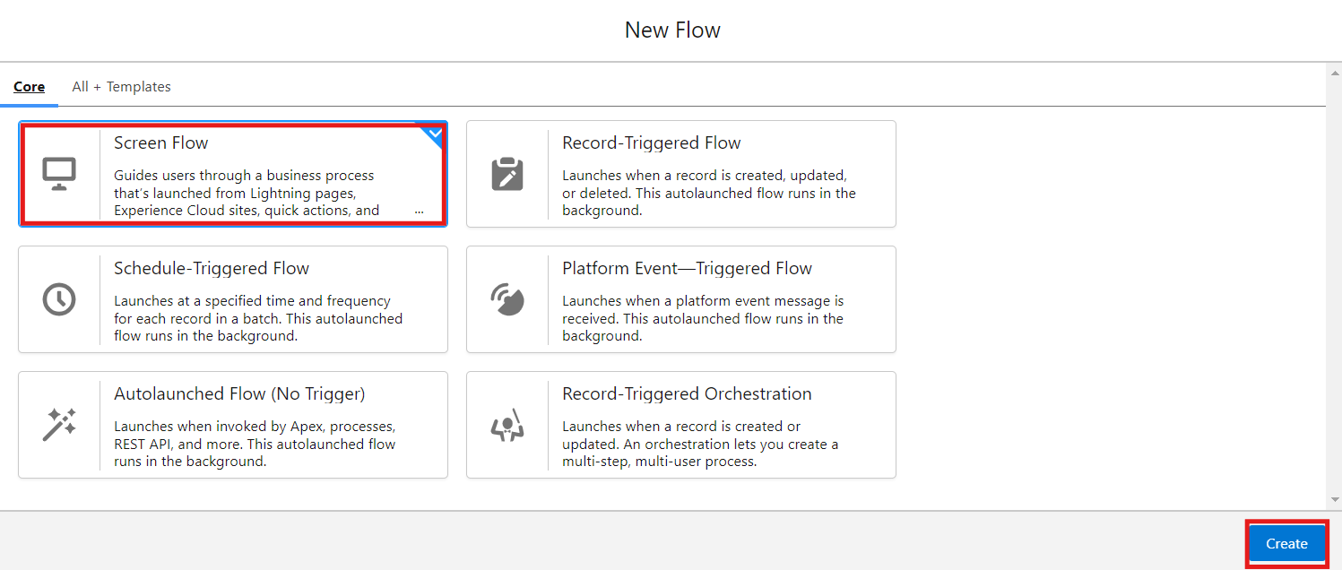

- Click (+) Icon on the flow builder and Select Screen Component.
Label : Players screen
API : Players_screen
Select the Picklist component and place it on the screen.
Label : Team
API : Team
From Component Pane on the left side select Component Type : Picklist
Data Type : Text
Choice : Click New Choice Resources
Resource Type : Picklist Choice Set

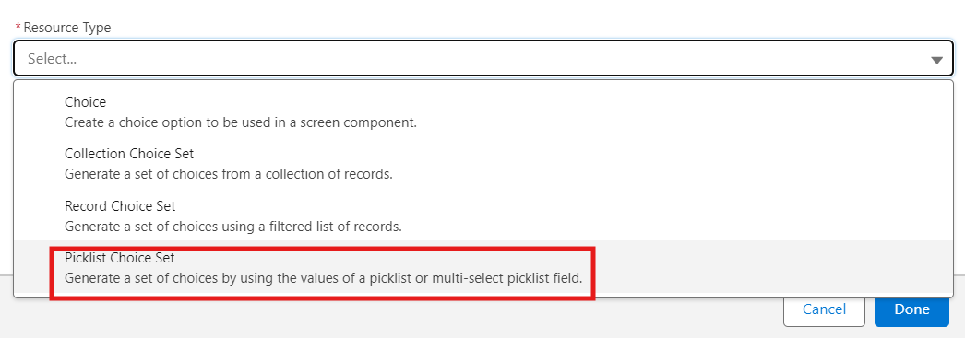

API Name : Team
Object : Player
Data Type : Picklist
Field : Team
Click Done.
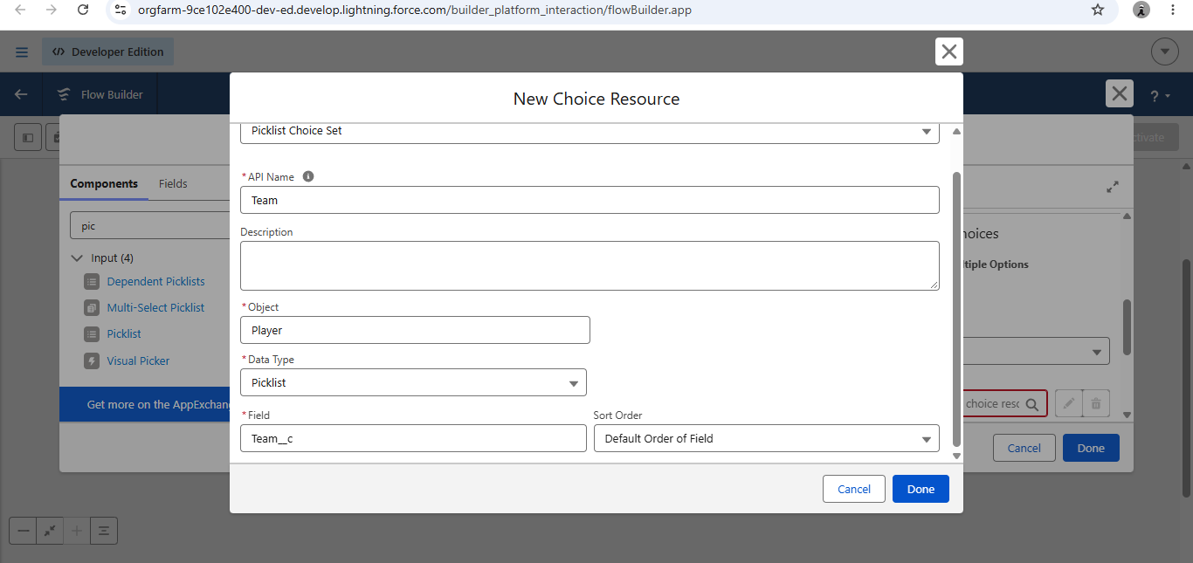

- Click (+) Icon on the flow builder and Select Get Records Component.
Label : Players
API Name : Players
Object : Player
Filter player records :
Field : Team
Operator : Equals
Value : Click New Resource
Resource Type : Variable
API Name : Dynamic
Data Type : Text
Default Value : Screen component : Team (Picklist)

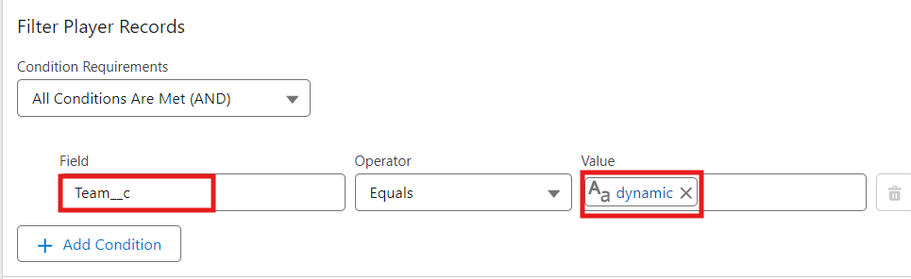

- Click (+) Icon on the flow builder and Select Screen Component.
Label : Player_info
API Name : Player_info
From Component Pane on the left side select Component Type : Data table
API Name : Player_info_table
Label : Data Table
Configure Data Source : Source Collection : Players from players (Player__c)

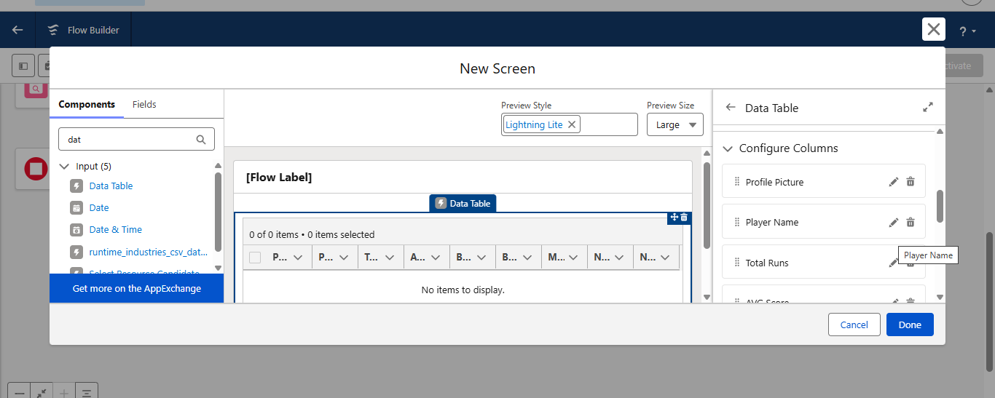

In Configure Columns : Add all the required Columns
Profile Picture | Player Name | Total Runs | AVG Score | Batting Style | Bowling Style | Matches Played | Number of 50’s | Number of 100’s
Click Done.

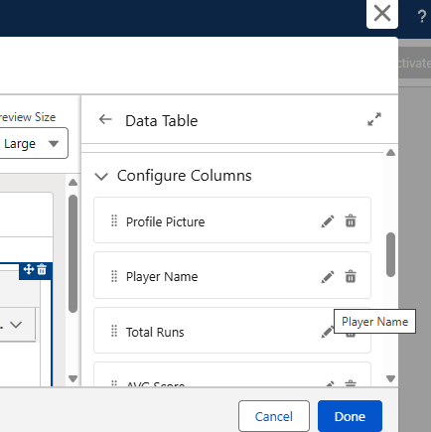
Click Save.
Flow Label : Player Flow
Flow API Name : Player_Flow
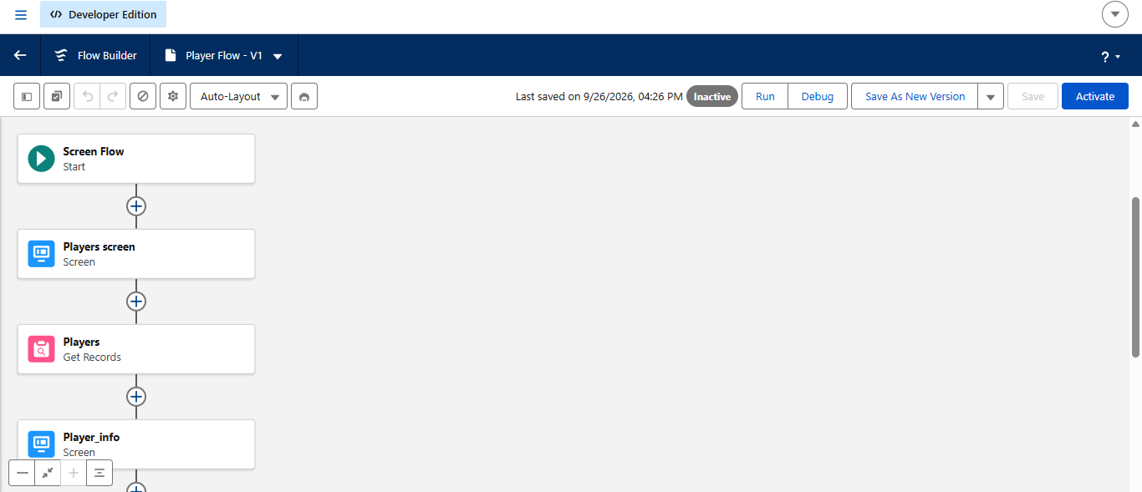
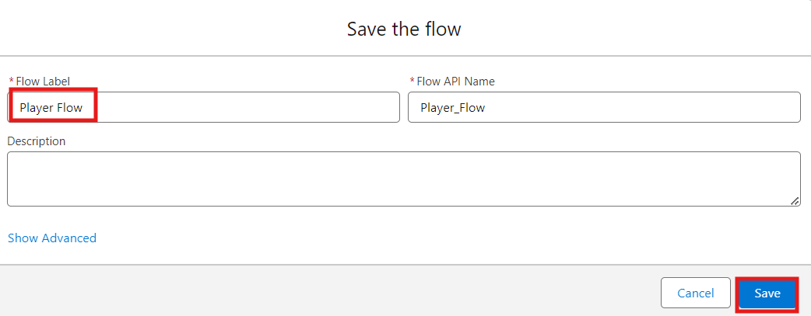

Activity 2 : Flow on Home Page

- On your CRICKSTATS Application on the top right of the Navigation Bar click on Personalize your nav bar icon (Pencil Icon) and Add Home Page and click Save.

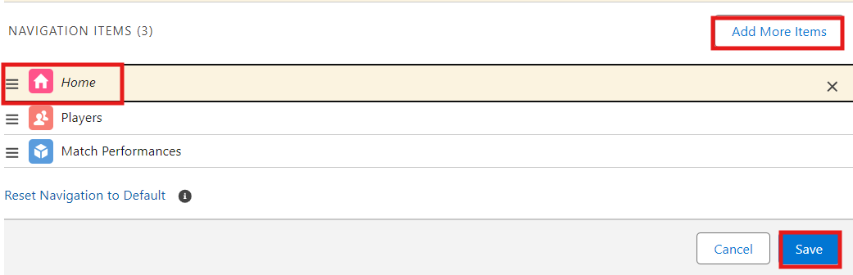

- Remove all other components and Add FLOW component from the standard components on the left side.
- Flow : Players Flow

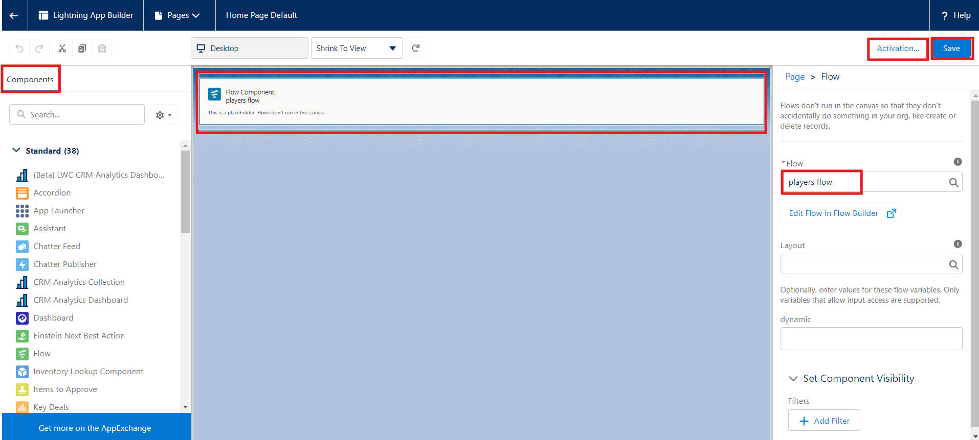

- Click Save and Activation.
- Click on App Default and select Assign to Apps.

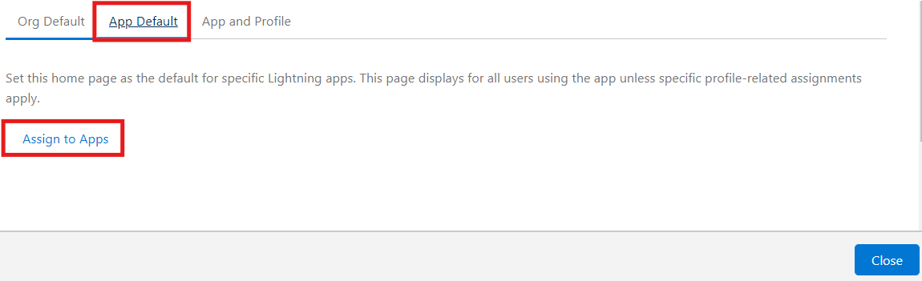
- Select CRICKSTAS App and Click Next and then click Save.

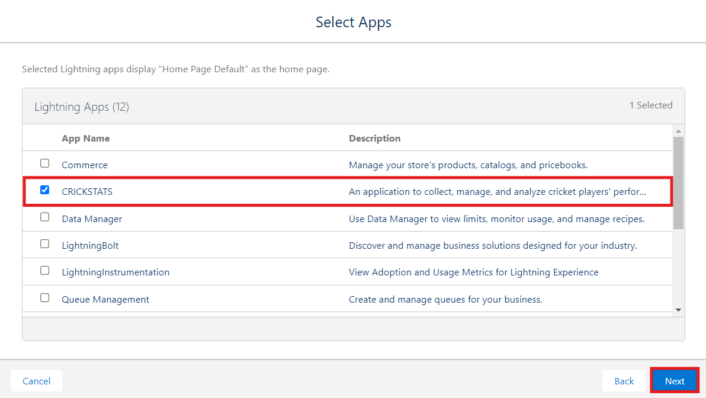

7. FUNCTIONAL & PERFORMANCE TESTING

The CRICKSTATS system was tested to verify the correct functioning of all major features. Testing included Player and Match Performance record creation, validation rules for mandatory fields and score limits, and verification of Domestic and International record types. The system’s flows and automation were tested to ensure automatic updates and data consistency. Roll-up summary fields were also checked for accurate calculation of total runs, wickets, averages, and performance metrics. In addition, system performance was evaluated during data entry, report generation, and dashboard loading to ensure fast and stable responses. Reports and dashboards were verified for accurate visualization and real-time updates. These testing activities confirmed that CRICKSTATS met its functional and performance requirements and was ready for deployment.

NOTE : Enter some records in the Player Object and Match Performance Object to get the results.

- Select one Team from the Picklist and Click Next.

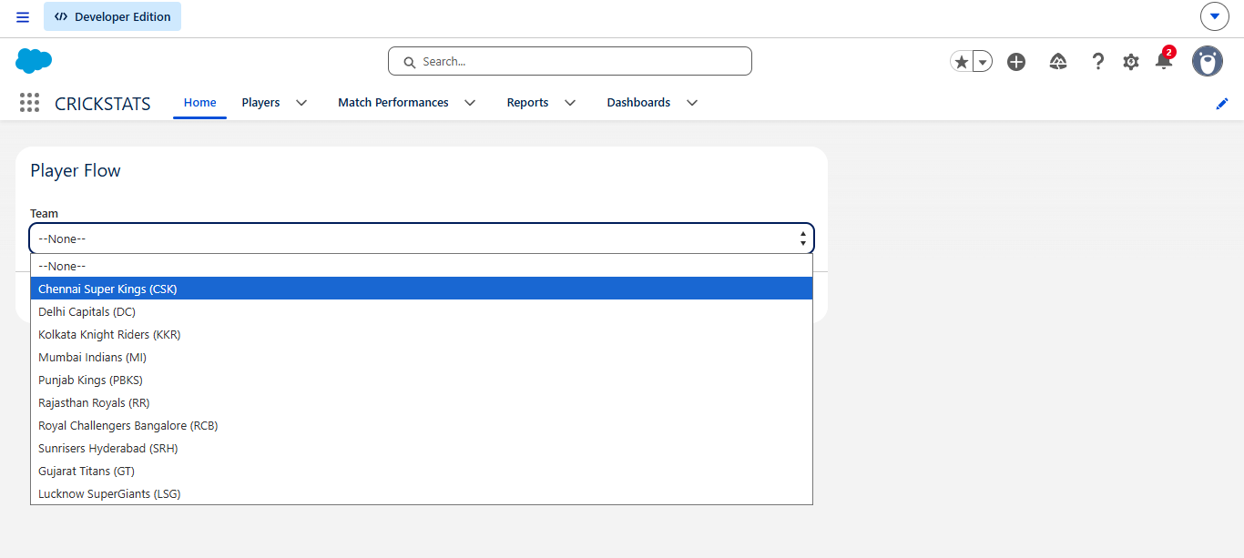

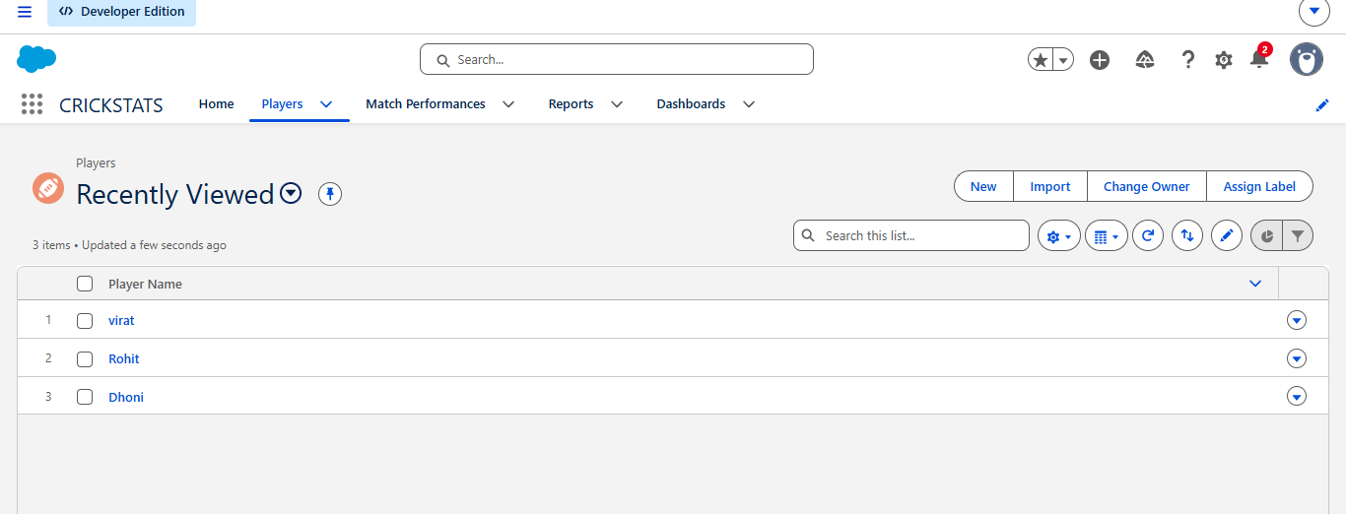

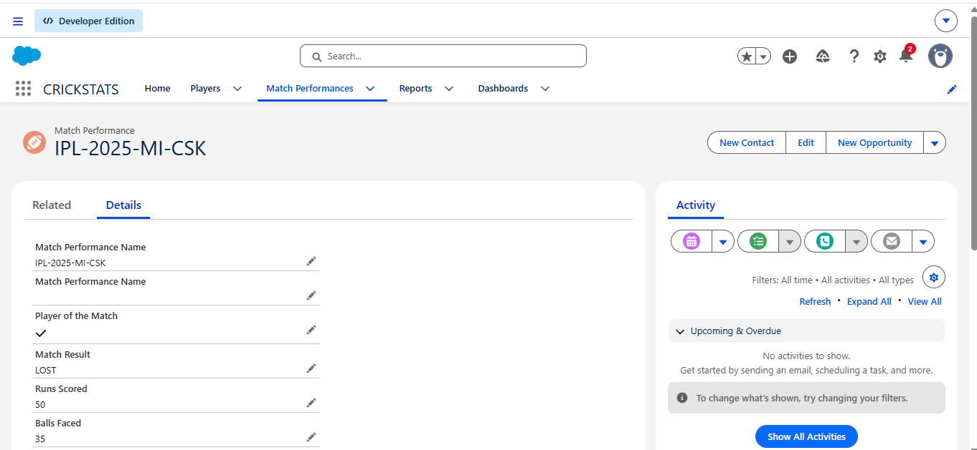

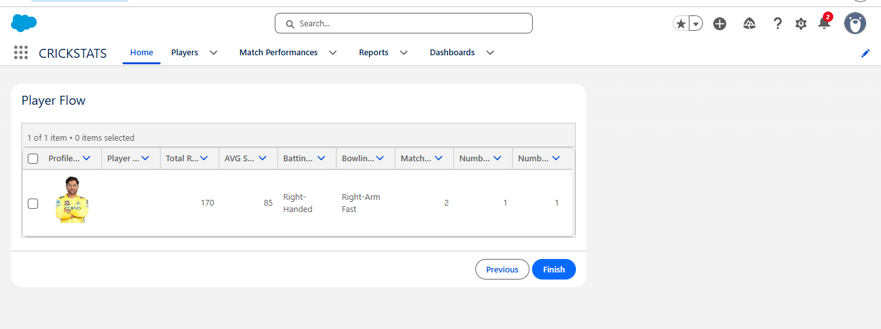

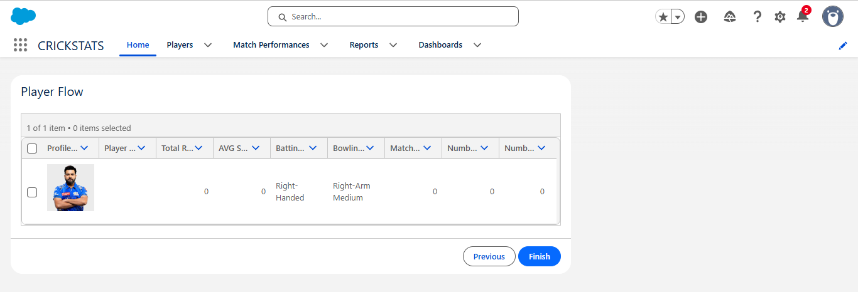

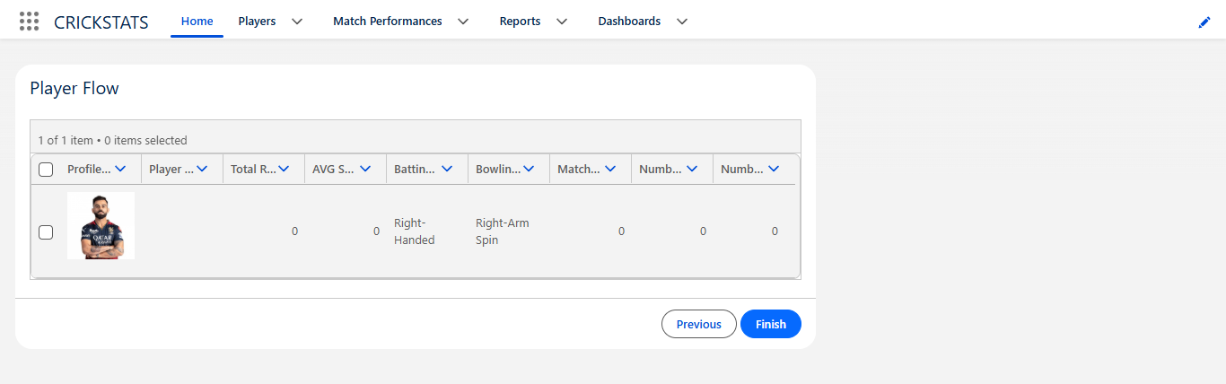

8. ADVANTAGES & DISADVANTAGES

Advantages
- Centralized system
- Real-time analytics
- Secure platform
- Scalable design
- Reduced manual work

Disadvantages
- Requires Salesforce license
- Internet dependency
- Limited offline access

9. Conclusion:

CRICKSTATS is a Salesforce-based cloud application developed to manage and track cricket player performance efficiently. It provides centralized data management, automates performance-related processes, and generates accurate reports and dashboards for analysis. The system helps coaches, analysts, and administrators make data-driven decisions and monitor player development. The project also demonstrates the practical use of SDLC, Agile methodology, Salesforce CRM, automation, and cloud-based application development.

10. FUTURE SCOPE

Salesforce Objects & Fields – Create Player and Match Performance objects with required fields to store cricket data.

Manual Match Statistics – Enter and maintain player performance details such as runs, wickets, matches, and scores.

Flow Configurations – Automate record updates, calculations, and notifications using Salesforce Flows.

Reports & Dashboards – Generate performance reports and display player statistics through dashboards.

Data Validation – Use validation rules to ensure accurate and consistent data entry.

11. APPENDIX
- Salesforce Objects & Fields
- Manual match statistics
- Flow Configurations

My team and I successfully created the required objects by following the instructions and guidance provided.

I developed the Cricket Player Performance Tracking Application – CRICKSTATS in my Salesforce Developer Org as part of our project.

Through this project, my team and I learned many new concepts and gained practical knowledge about Salesforce development, data management, and tracking cricket player performance. We learned how to create and manage records related to players, matches, teams, and performance statistics.

The project helped us understand how Salesforce can be used to develop an application for maintaining and analyzing cricket player performance efficiently.

My team and I made our best efforts to complete the CRICKSTATS project successfully and gained valuable practical experience throughout the development process.

Thank You

